1. **Login/Register**

This define requirement for functions which relate to User‘s Action on Login/Register Page.

* When User request Browser web 🡪 Log in/ Register Page always be the first page display to user can Sign In ( If user have account) or Sign Up an account if User does not have account in Bsportteam
* When Login/Register Page be shown up on screen, default language is English(US) will be used in content of this page
* User do action log into account of bsportteam when user click button Login on the right corner and UI pop up displaying 🡪 **“Remove”**
* User input email and pass to log in website successfully, this page will redirect to Account Profile Page and Activities Tab content will be activated
* If User input wrong information login, red string will be displayed “ Your password or Your email is false, please Input these again
* If User click on forgot password, this will be redirected to Reset Password Page then User input usermail which user registered and click “send “ button. System will send one email to this email .in this email will contain a link that link to Getting New Password Page
* User do registration after filling in form registration new account then click “Create” button. If this action is successful, this page will redirect to Account Profile and “Edit Profile” Tab content will be activated

This part belong to footer content

* Click on MENSPORT open new tab page and show up Info Page Portal with filtering sport for men
* Click on WOMENSPORT open new tab page and show up Info Page Portal with filtering sport for Women
* Click on KIDSPORT open new tab page and show up Info Page Portal with filtering sport for kids
* Click on HELP open new tab page and show up Info Page Portal
* Click on ABOUT US open new tab page and show up Info Page Portal with filtering sport for men

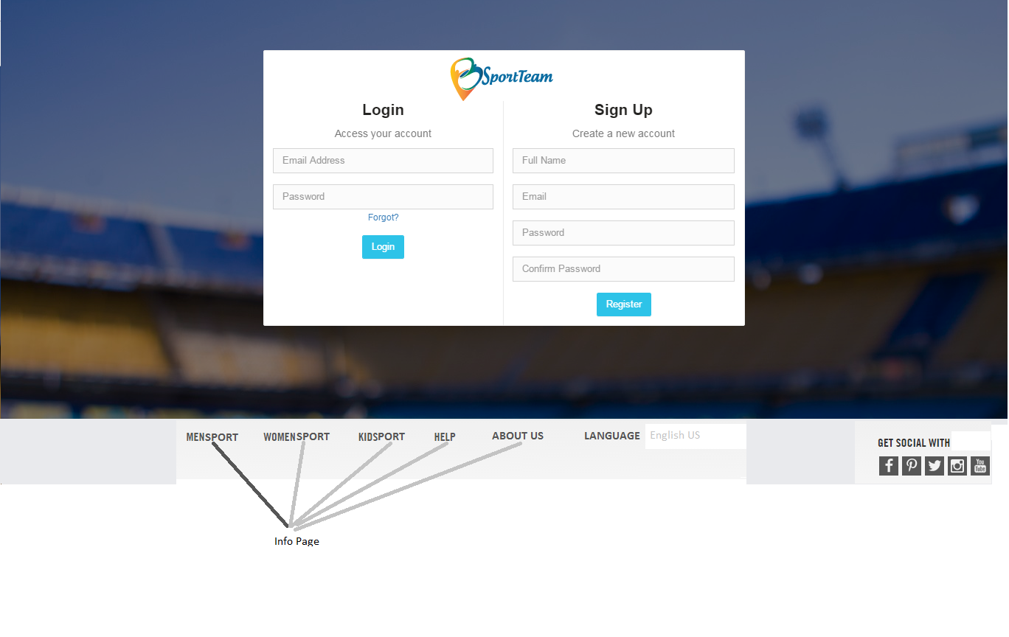

Figure 1: UI Login/Register Bsportteam

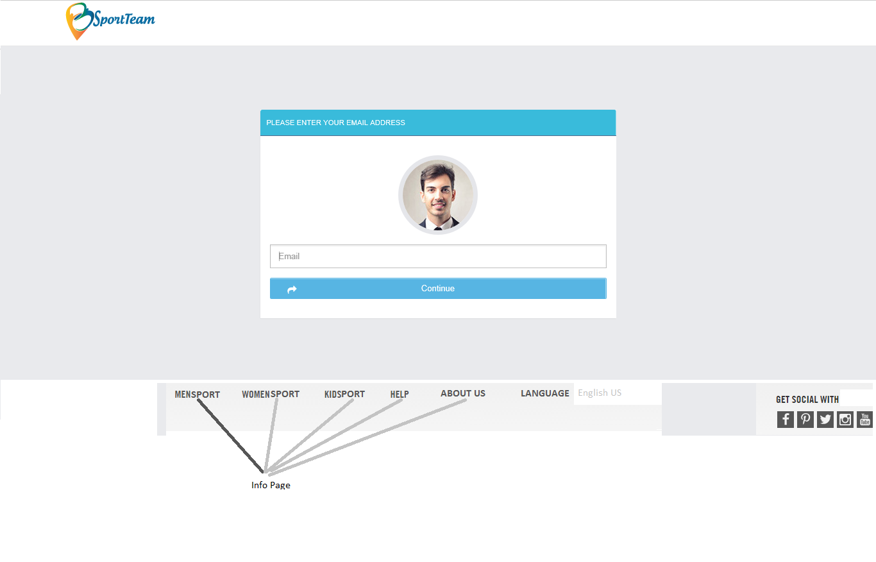

Figure 2: Request Reset Password

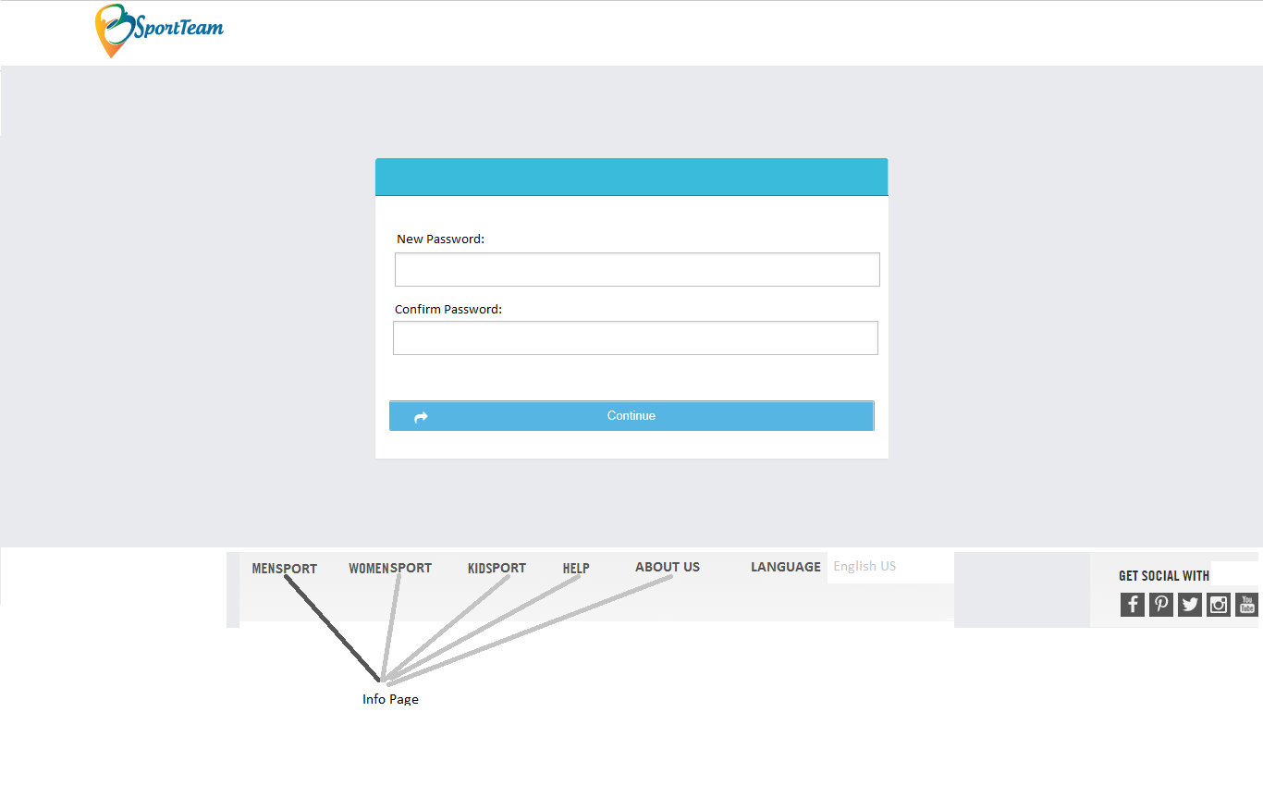

Figure 3: Reset Passoword of Bsportteam

1. **Info Page**

This is info page which footer of Log in/ Register pages will be linked to this page. The purpose of this page is provide or support information and introduction that bsportteam contains. Therefore It could be Sports ( All sports which bsportteam support), Stadiums ( All places which Bsportteam link or have data in system), FAQ, About Us ( introduction about Bsportteam).

UI Info Page have four main components. There are Header, Navigation, Footer and Content

* **If user does not have account or not yet signed in Bsportteam, Header of info page will be**



* **IF user logs in successfully Bsportteam, Header of info page will be pictures below. This design header will be used over other pages**

We don’t show avatar of user on header. It just be icon and user click and then pop up be showed up Edit profile and sign out. When user click on Edit Profile 🡪 redirect to Edit profile page and click on sign out 🡪 redirect to sign in and register page

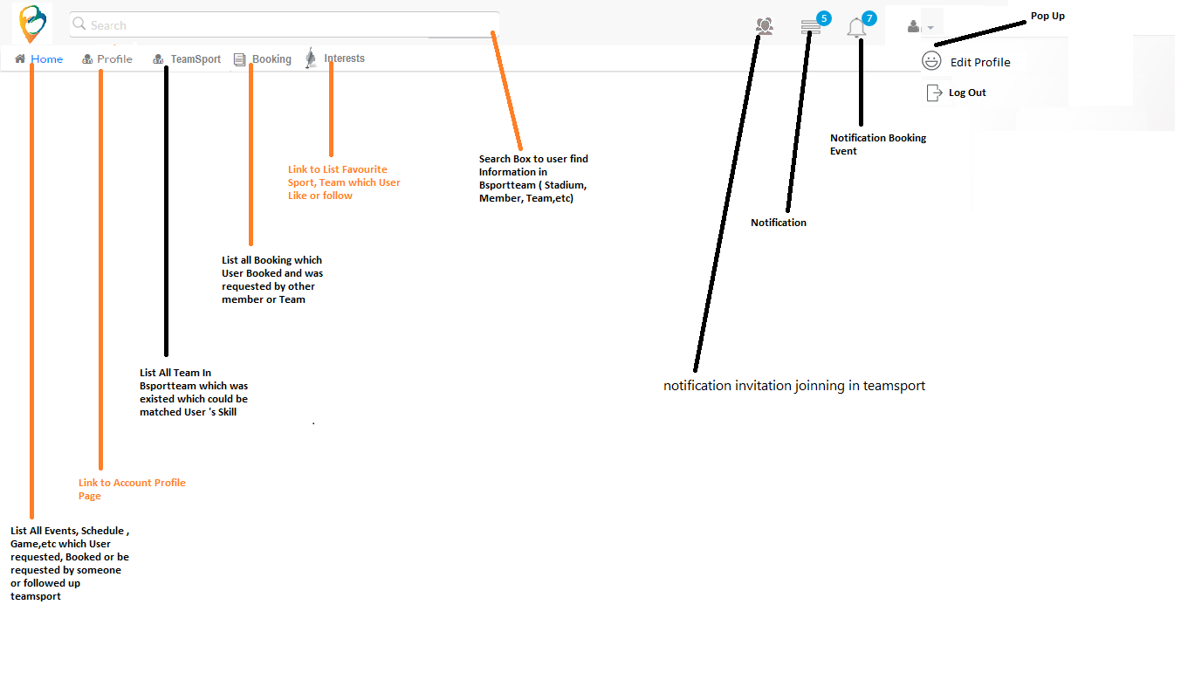

Figure : Header picture

* **Footer of this page like other footer pages**

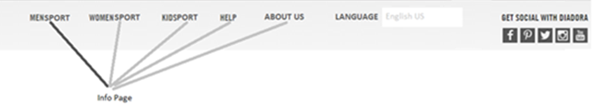

* **Navigation locate on left side of this page**

**When User click on each tagdiv of navigation, the content for this tagdiv will be displayed**

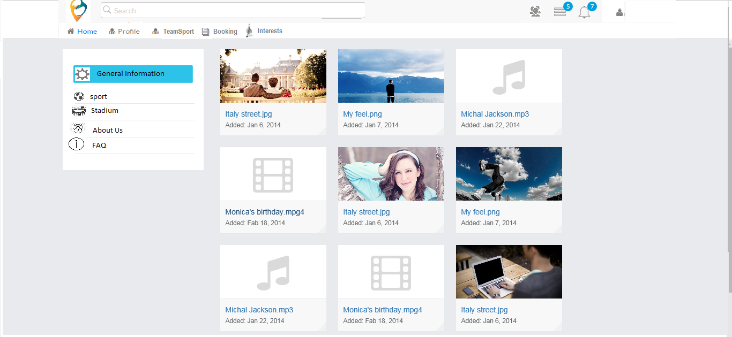

* 1. **Sports Support by Bsportteam**

The content of Sports here just list out all



When User click on Sport navigation on left side bar

UI Sports will be displayed with

Country: default value that is Country’s User and Gender is “All”

The result will be displayed, is all Sports which Bsportteam supports to this country. It contains name of sport and Image for this Sport.--> remove

The data of Sport is master data and Bsportteam set up data for this

* 1. **Stadium in Bsportteam**

The content of Stadium here just list out all Stadium after filtering by country, city parameters



When User click on Stadium navigation on left side bar UI Stadium will be displayed with

Country: default value that is Country’s User and City is the current city of user

The result will be displayed, is all Stadium which Stadium joined in Bsportteam. It contains name of sport and Image for this stadium. When User click on stadium, Pop up will be displayed and show information detail about Stadium ( template not yet defined )

The data of Sport is master data and Bsportteam set up data for this

* 1. **FAQ**

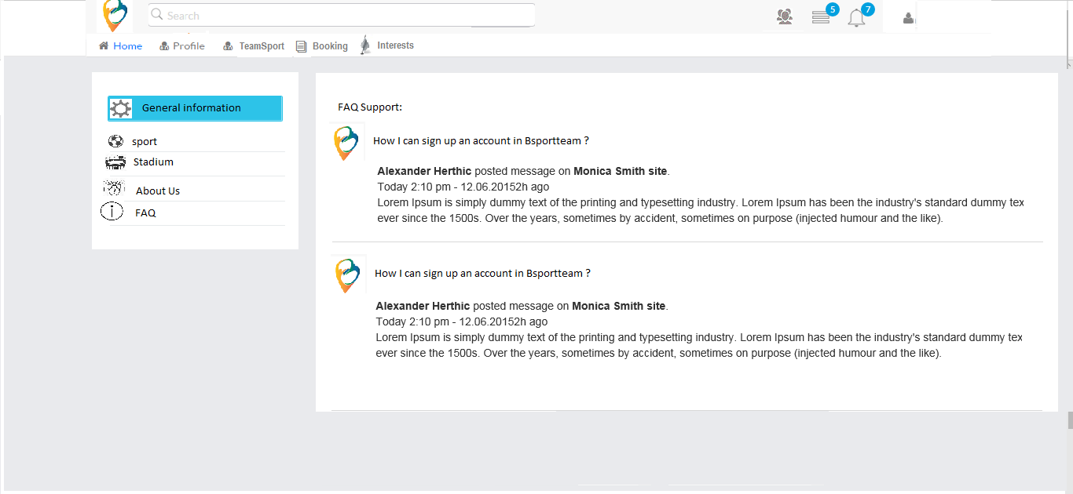

When User click on FAQ navigation on left side bar

UI FAQ will be displayed and List textbox questions will be showed like picture and

User see the answer of these question, User just click on TextBox question and the answer will be displayed like this 🡪remove

The data of Sport is master data and Bsportteam set up data for this

1. **Account Profile**

When User create account successfully, Account Edit Profile Page is the next page which user will do action

* If User is new user, After Creating Account from Log in / Register page will be redirected to Account Edit Profile Page and Profile Tab is activated firstly.

Update information:

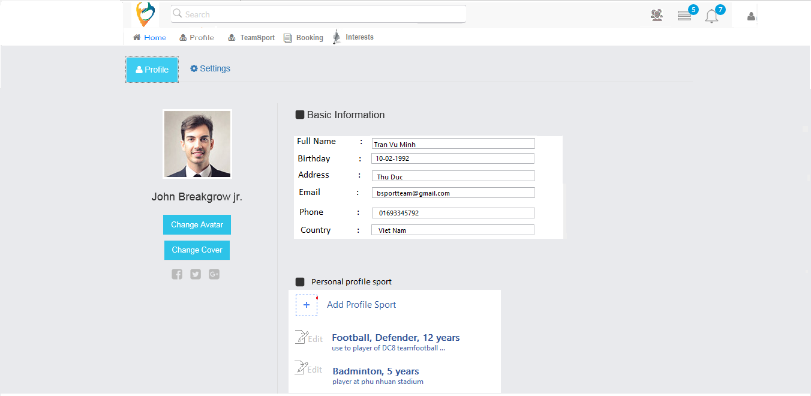

Figure 1: Edit account profile

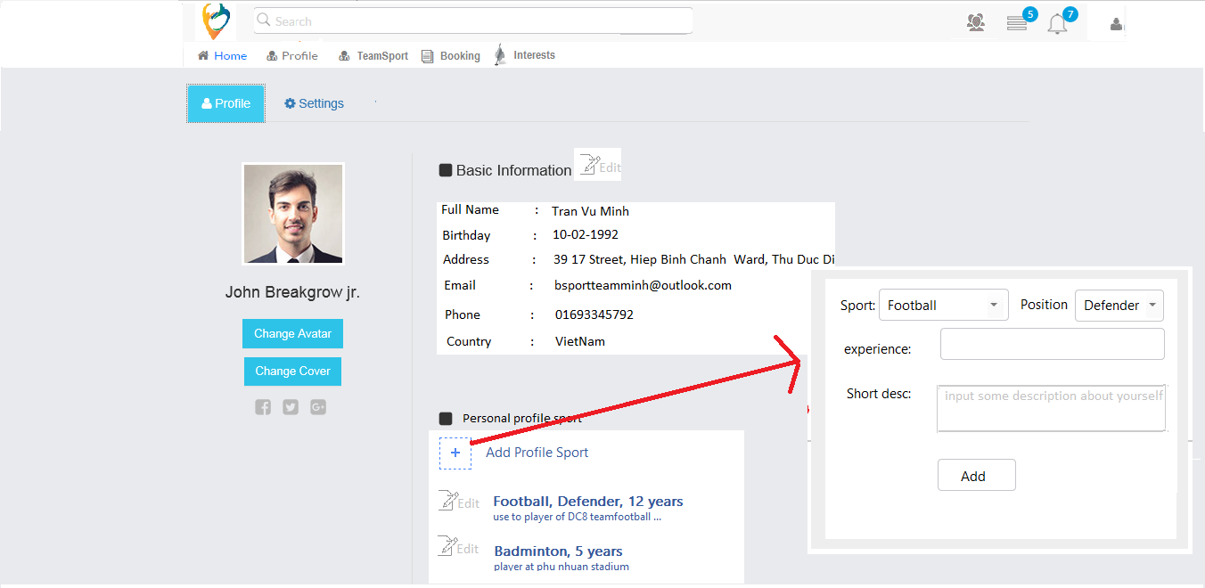

Figure 2: Add Profile sport

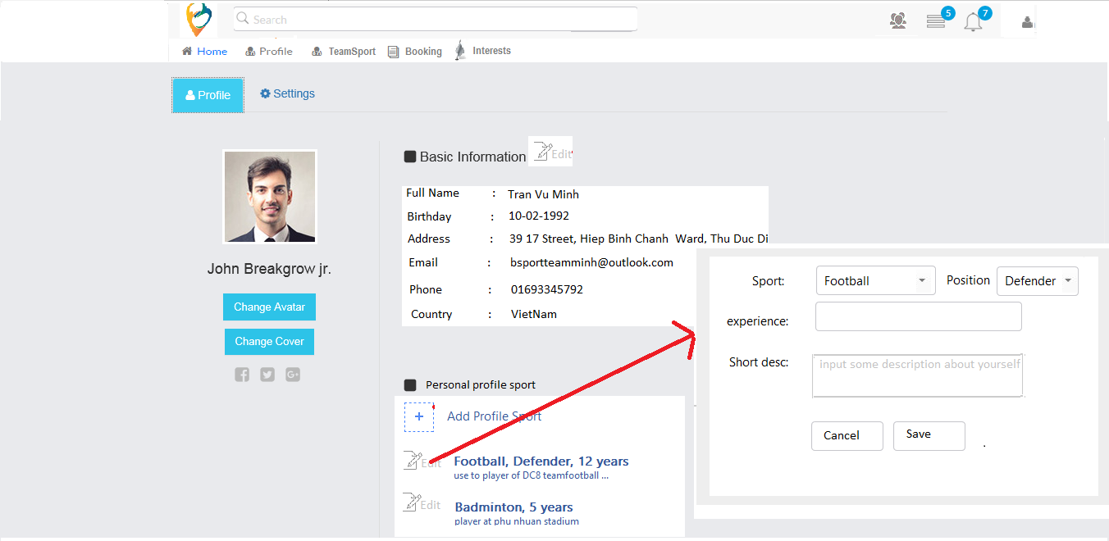

Figure 3: Update Profile Sport

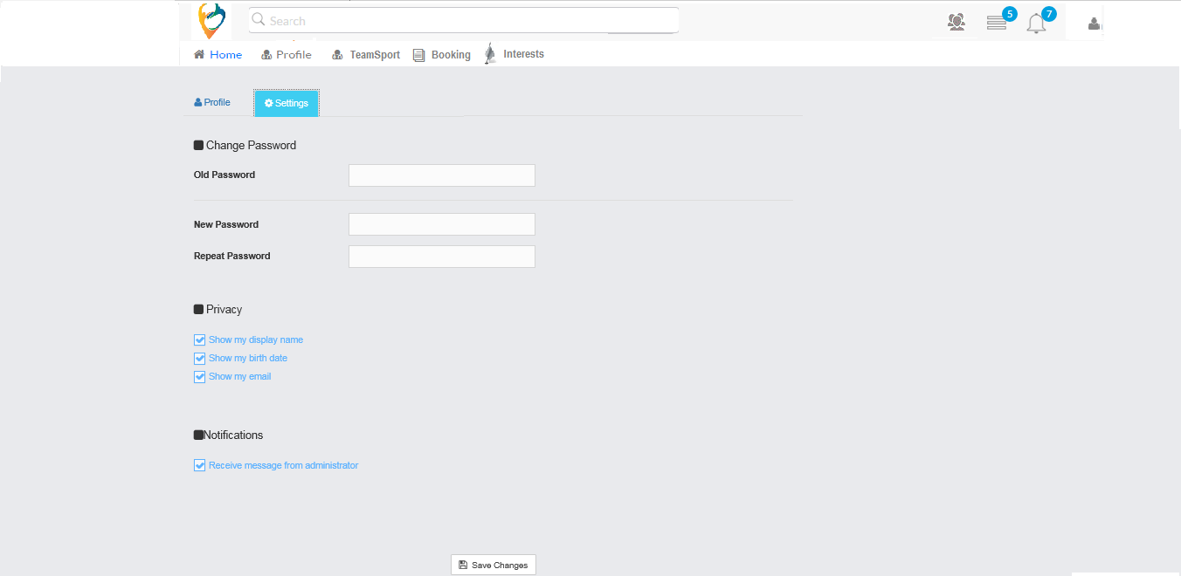

Figure : Setting Account Profile

* If User log in to use account, after logging in from Log in / Register Page will be redirected to Account Profile Page and Daily Activities Timeline Tab is activated firstly

Remove this picture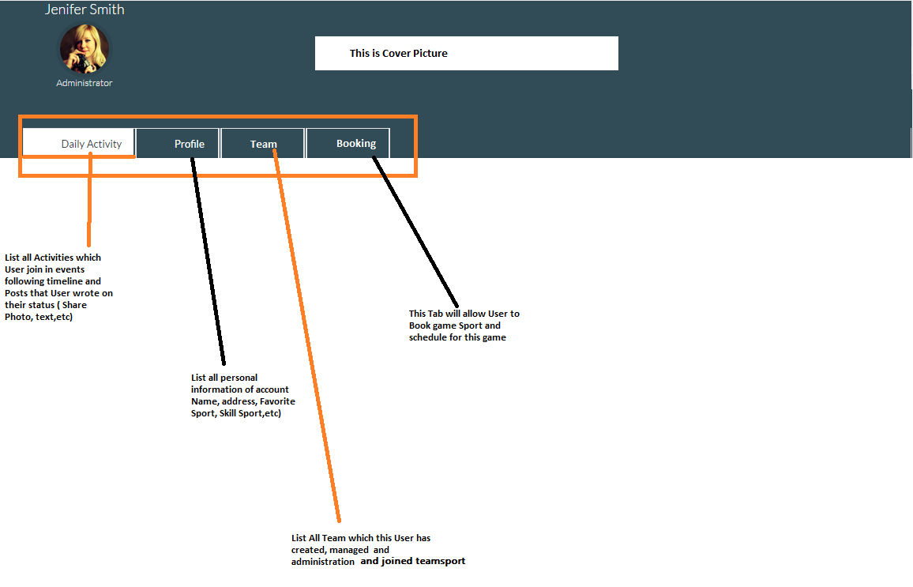

No change logic flow function, just change layout design as below picture

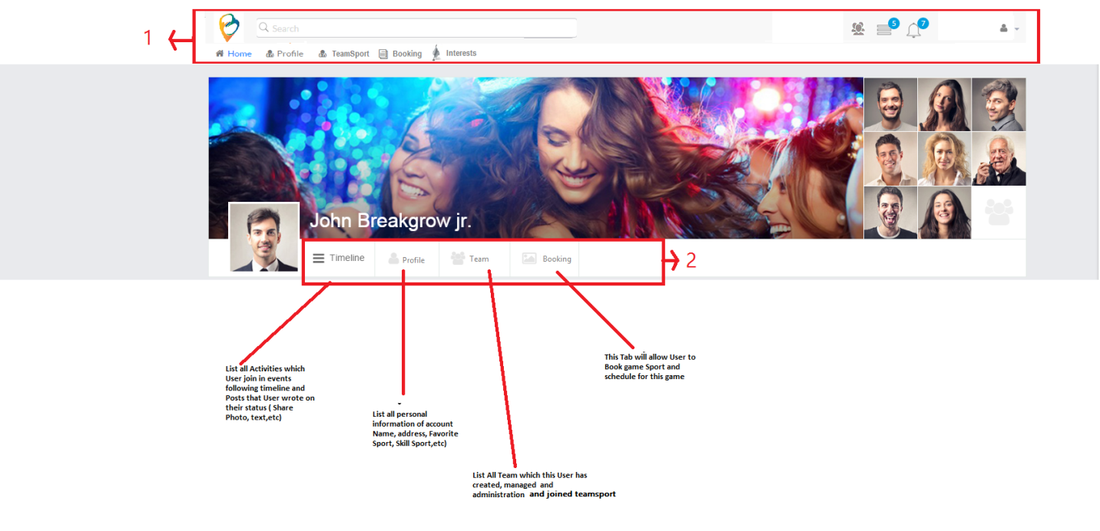

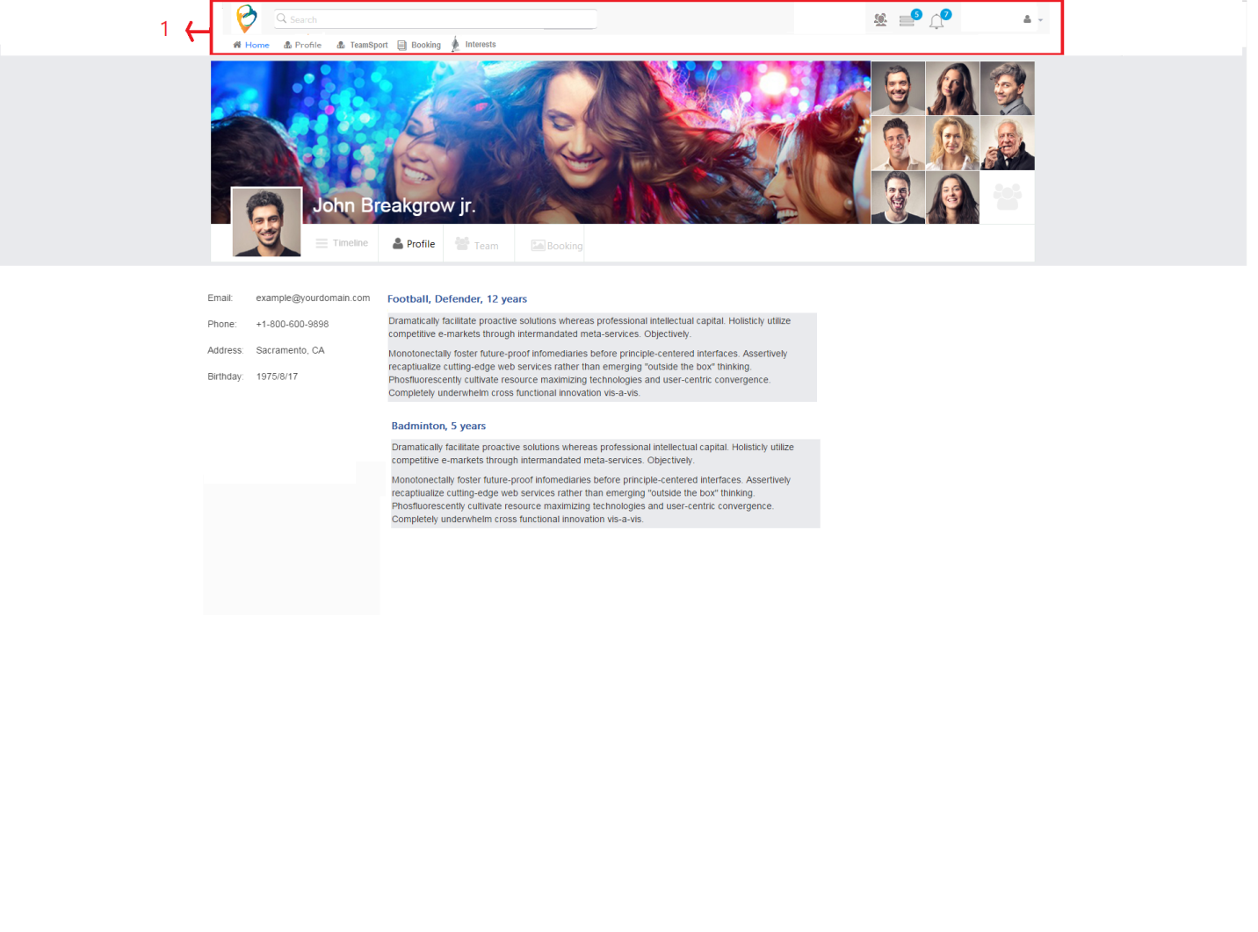

Figure 5: Account Profile Content Page Bsportteam

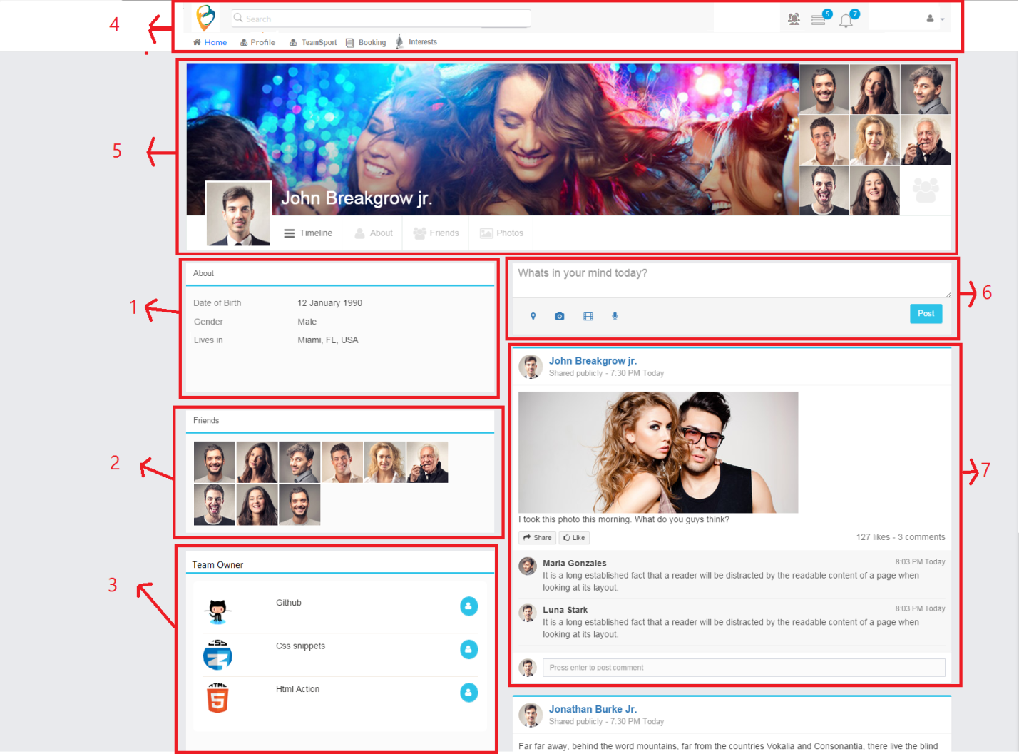

Index 1 : Show personal information as setting account profile

Index 2: show some member of teams

Business rule : not define just temporary random member ( maximum 10 members on this component)

Index 3: Show Teams which this user is owner

Index 4 : header

Index 5 :

* Cover
* Avatar
* Tab content ( Timeline, Profile, Team and Booking ) as describe above

Index 6: temporary not yet define waiting for new update

Index 7 : whole post share activities in any team page which user posted and booked schedule game

1. **Account Team**

When User click on Team Tab, this Tab will allow user to create Team and display all Teams which User created and managed. Concurrently , this tab also show up TeamSport which User joined

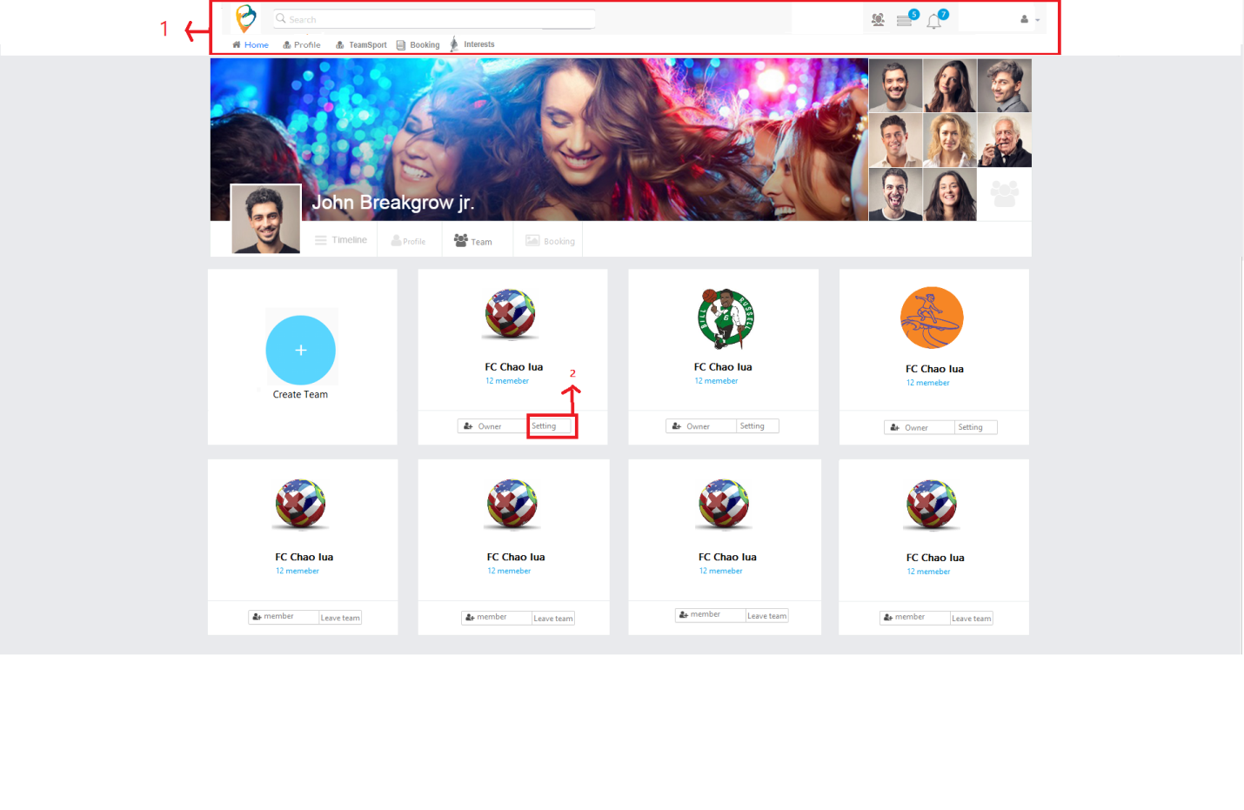

Index 2: not define

When User clicks on “Create Team” Button. This page will redirect to the creation team’s page

When User click on the name of team which hover mouse on words will be changed blue font. This page will redirect to teamhome page.

The form registration team’s sport: User will fill in information in two screen to complete signing up team’s sport

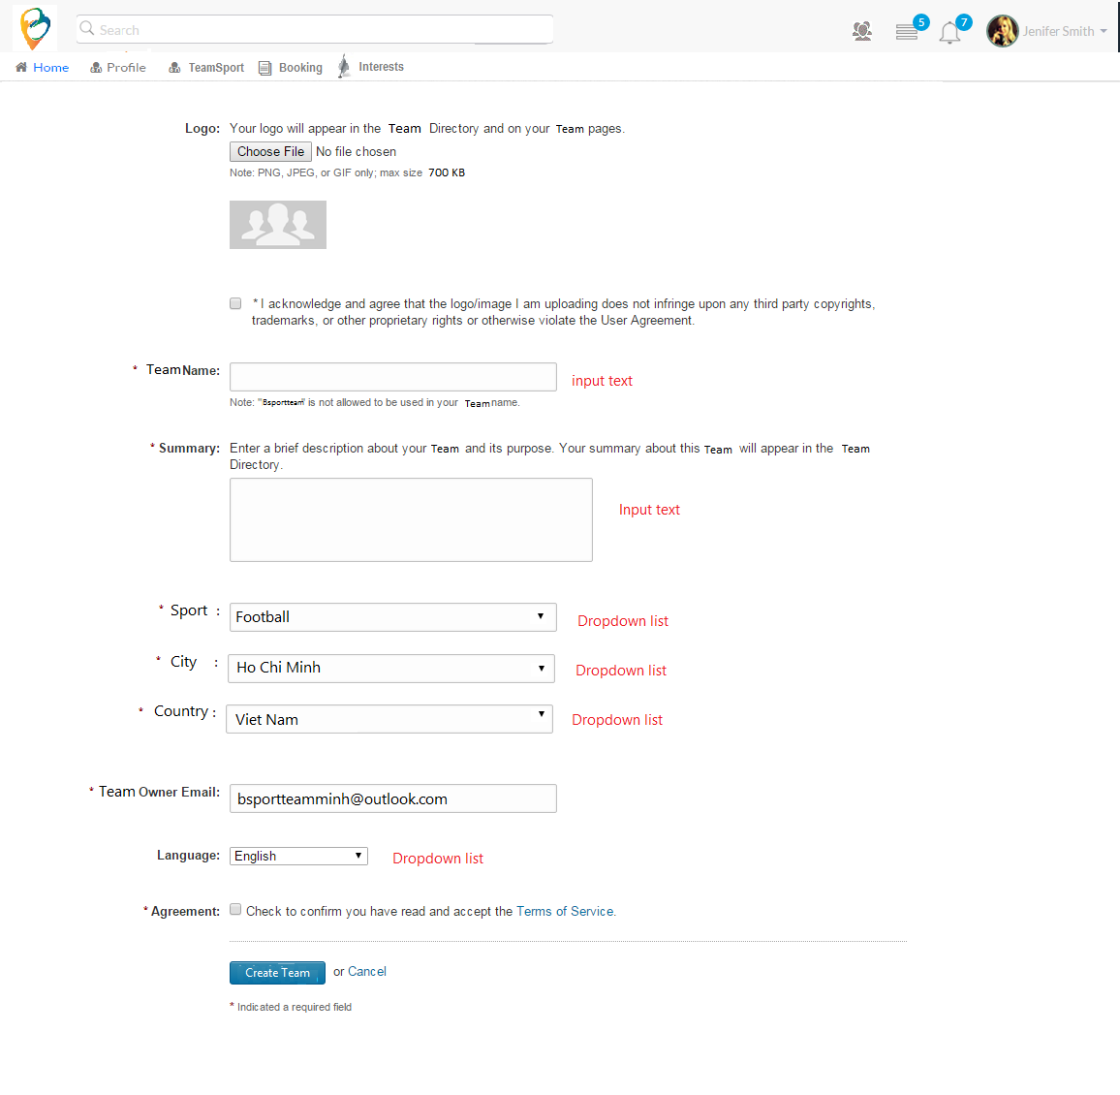

Screen 1 : fill in information for Teamsport

1. **Account Booking**

When User click on “Booking “tab. The content of this tab will be showed up

When click into “Book your game” , one pop up will be showed to user schedule their game . User will search Team name on text box and click “ Add “ button to completely choose team and Team was chosen which is displayed below text box (Team). User continue choosing (Time, Date , Stadium and write short description if need) and Click “ Book” to complete booking

After successfully booking a game, the whole information of booking will be displayed like picture that described

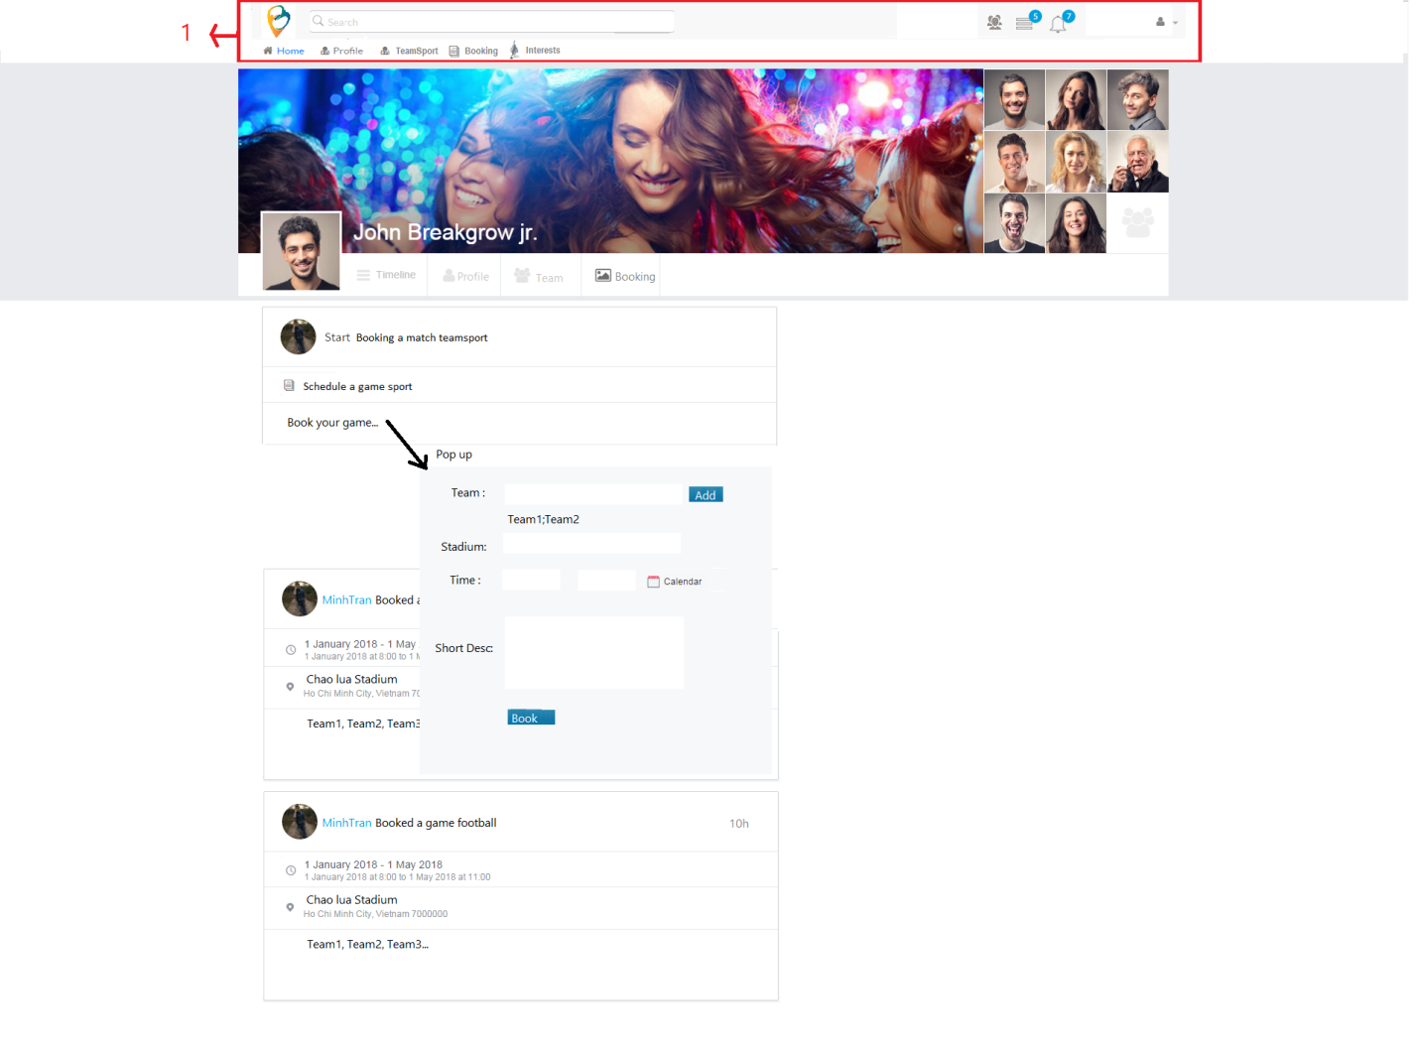

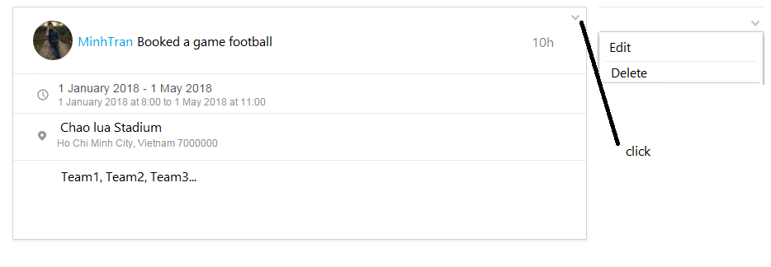

1. TEAMSPORT

After submitting button “Create Team” at Form Registration, system will use all information to create a team which user created will be highest role administrator to manage this team.

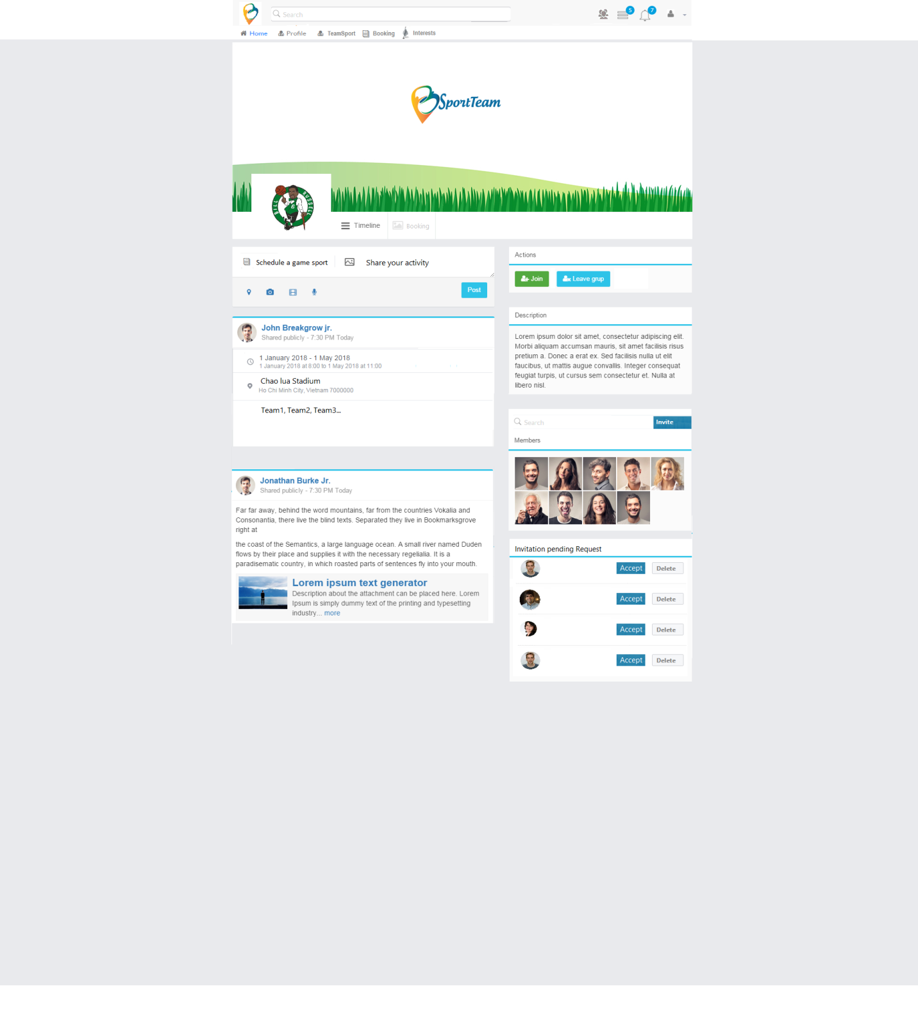

New picture

As you can see right side

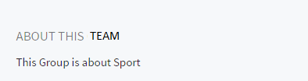

Remove this picture

This is short description which User inputted while creating team

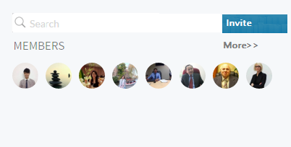

Remove this picture

This is used to Search member and Add to Team. Some avatars of members will show here, When User click “More” will redirect to “Team” Tab of Team Homepage. Because “Team” Tab of Team Homepage will list all members of this team

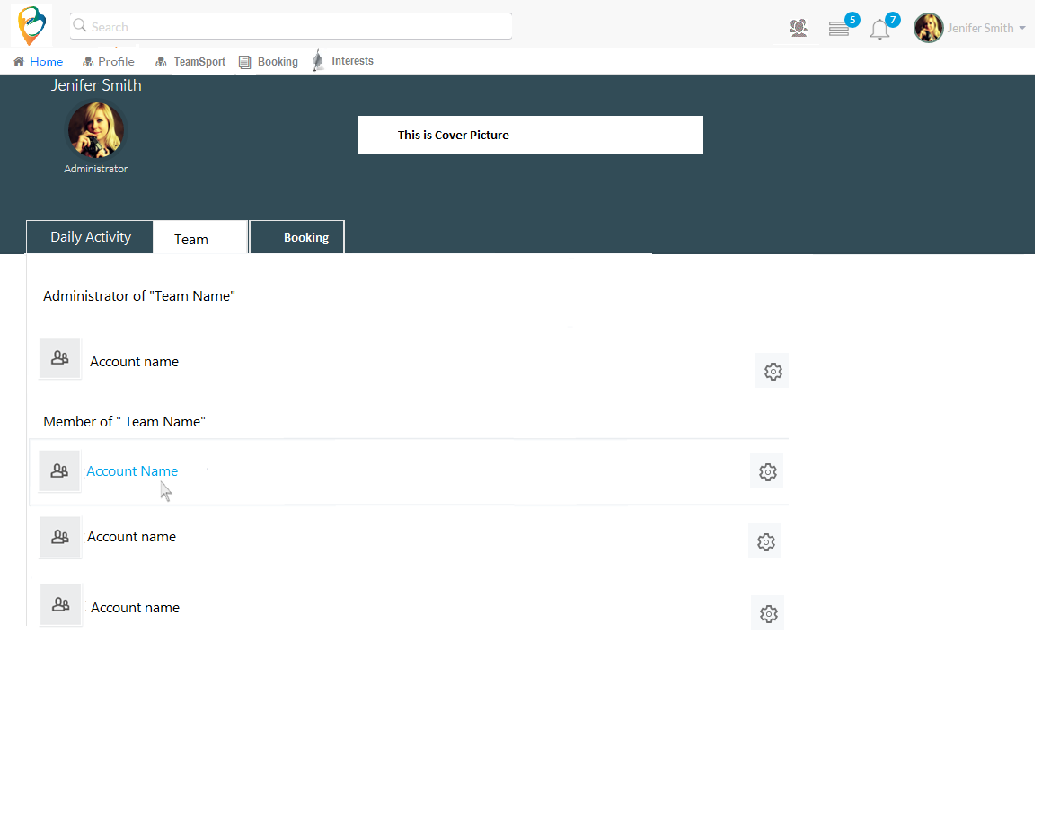

Remove this picture

Team Homepage will have three tabs

One is “Daily Activity”, this is where contain all activities of this team (Booking, Share information),this tab is defaulted when user request to this team

Two is “Team “this tab contains all members of this team and Setting of this team

Three is “Booking” this tab contains booking which was booked in 30 days

In “Daily Activities” Tab

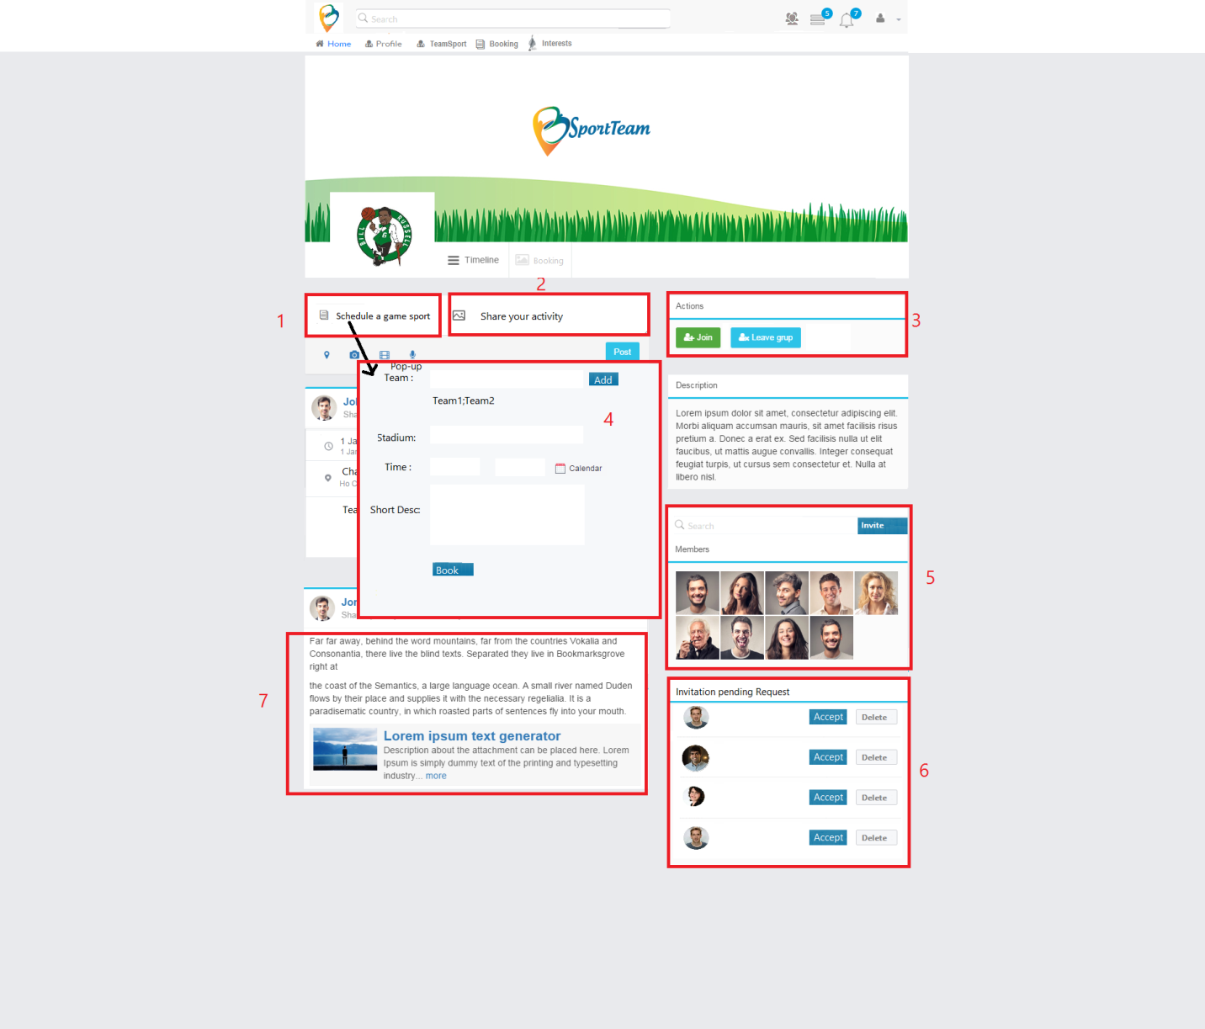

New picture

Index 1: Click and then pop- up will show up to schedule booking game

Index 2 :

When User start to input data in “share your activity” the button “Post” will be active and if user click another tab while not yet completing content of post example : you are composing content of post, but not yet completed , user accidental move another tab “ Schedule a game sport” to do, that time system will pop up announcement to force user that user is sure to “leave edit content”.

When Pop up Display, just pop up activate and another function will be disabled (blur color)

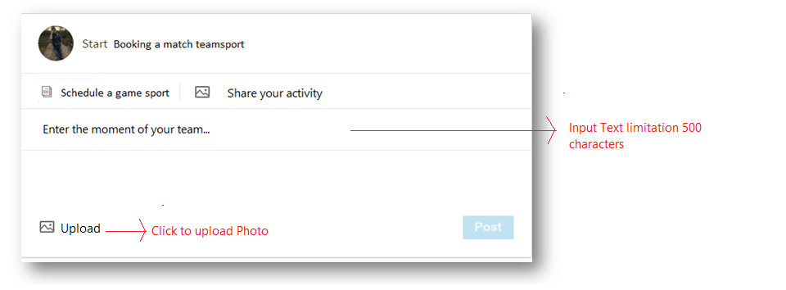

Figure : Picture was updated

Index 3 : If user is member of team , only “ Leave group “ show up else only “ Join “ show up

Index 4 : form booking game

Index 5:

Any member input data in search box from right side component in team’s page, the system will search member in Bsportteam and show up data result like input of user. When member search successfully user that want to add into team, member click button “Invite”

Default in team page we show 9 members first of team and if member of team want to see all member, user click on “Member” Text and it will redirect to team member page like pic

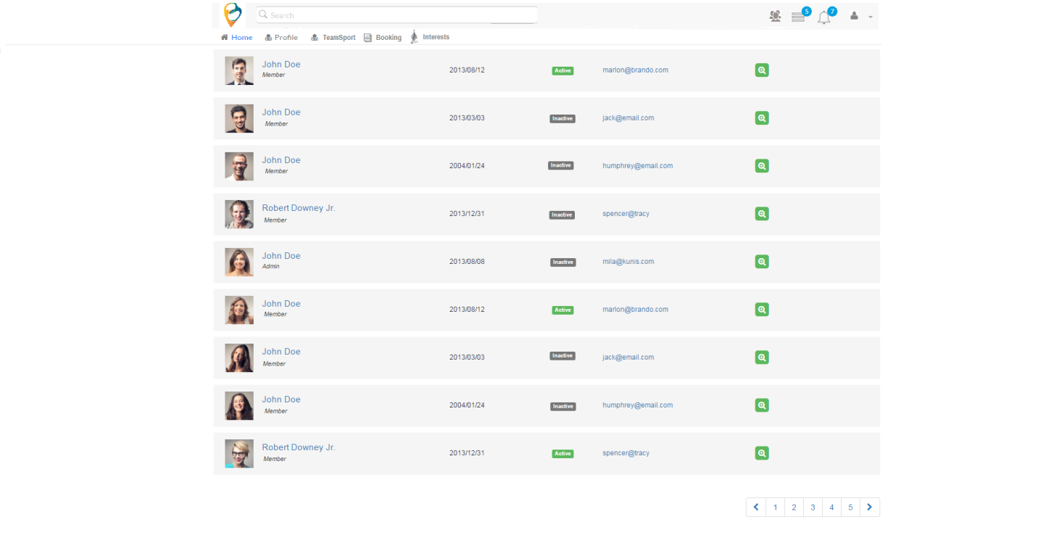

If you are admin of this team when click “member” text it will redirect page like pic

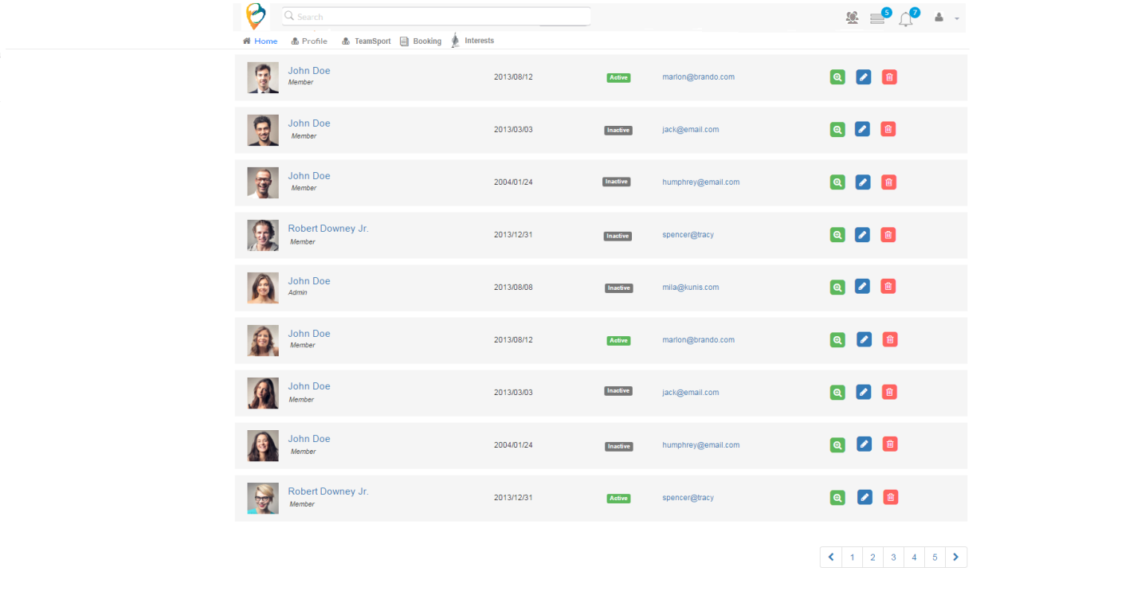

Index 6 : this component only show up if User is Owner of this team

When anonymous user request to join team or member of team invite another user to join team. All request will show up in this component and waiting for accept from Owner of this team

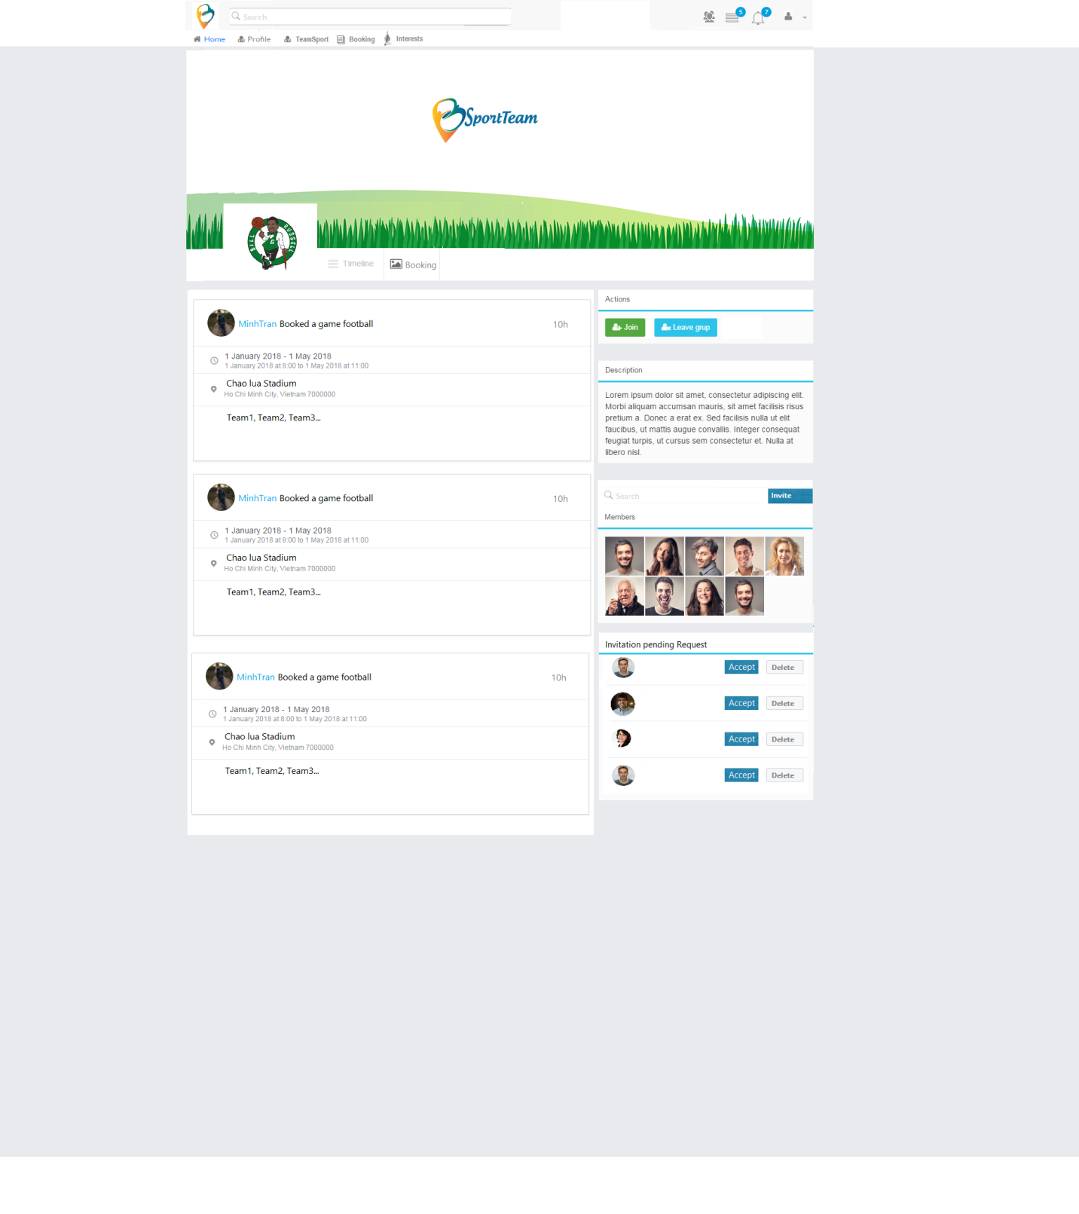

Team Booking Just shown up All booking of team which order descending ( Latest to oldest )

User has two choices, one is “Share your activity” and two is “Schedule a game sport”

The picture you can see above is describing the form information of “Share your Activity” to user share Image, text about activity which user joined.

**Update information**

When User start to input data in “share your activity” the button “Post” will be active and if user click another tab while not yet completing content of post example : you are composing content of post, but not yet completed , user accidental move another tab “ Schedule a game sport” to do, that time system will pop up announcement to force user that user is sure to “leave edit content”.

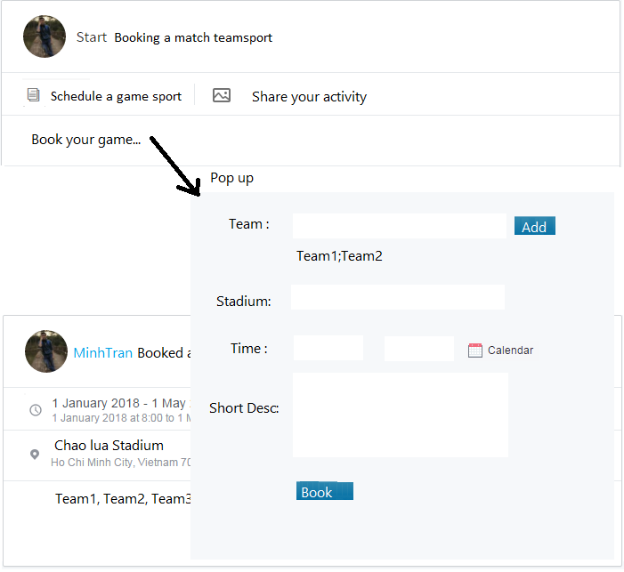

This picture is describing the form which allow user to do booking a game sport. When User put the point of mouse computer in “Book a game” Pop up will be showed to help user can book a game sport.

**Update Information**

When Pop up Display, just pop up activate and another function will be disabled (blur color)

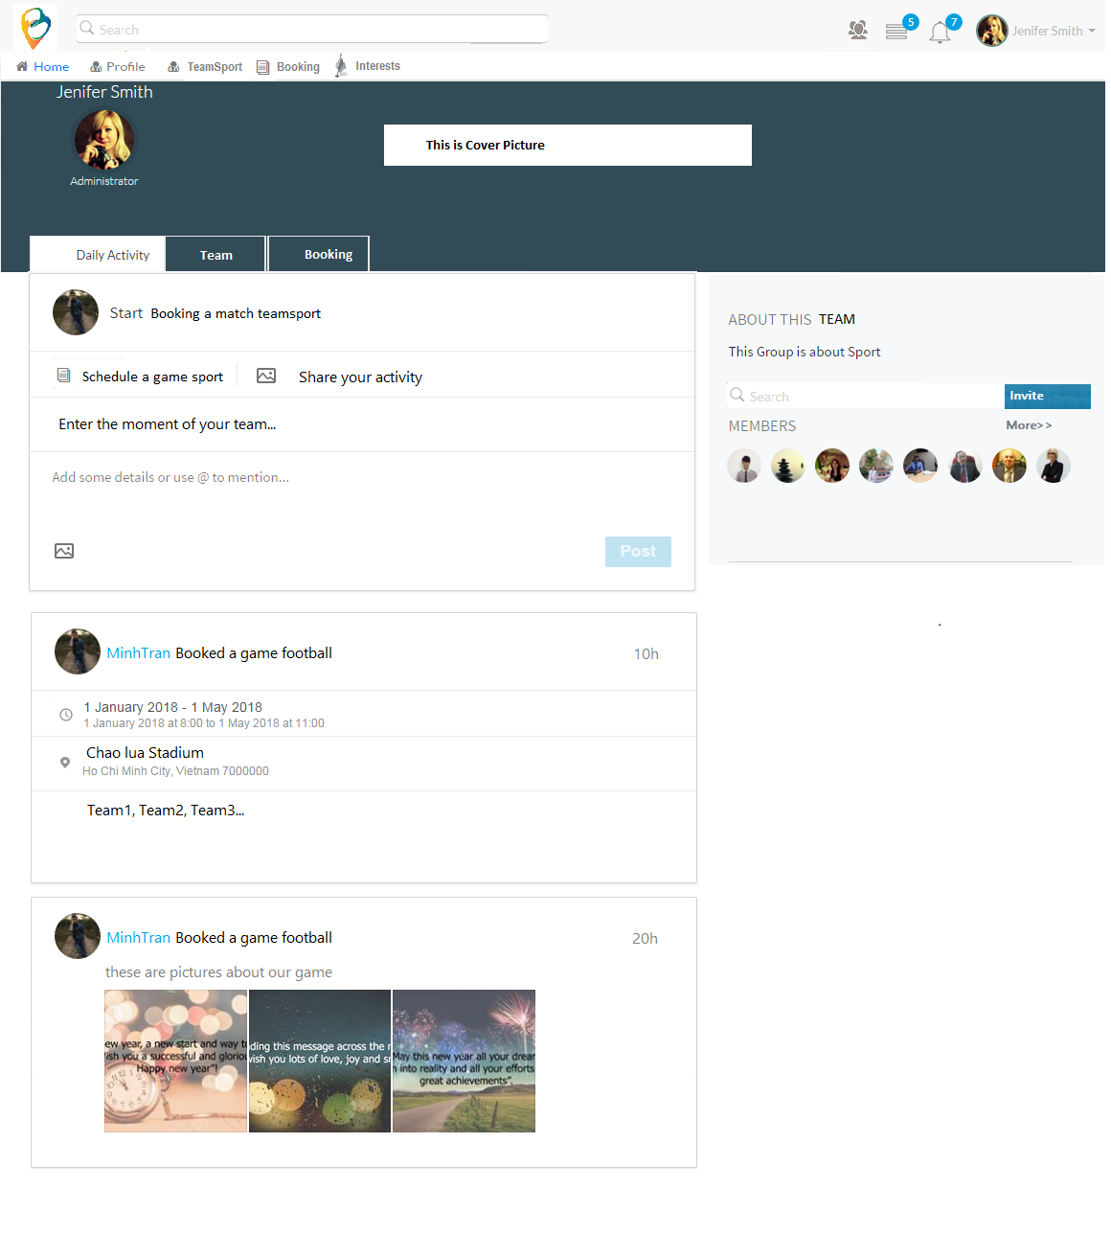

Remove picture

**Right side component**

Note: Right side component as you can see in pic below always show up all tab of Team Page ( Daily activity, Team, Booking)

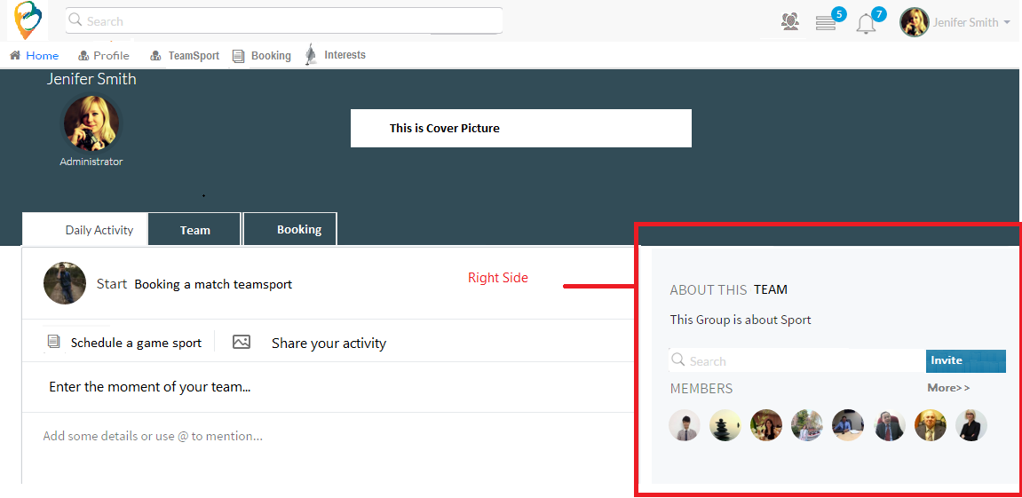

Remove this picture

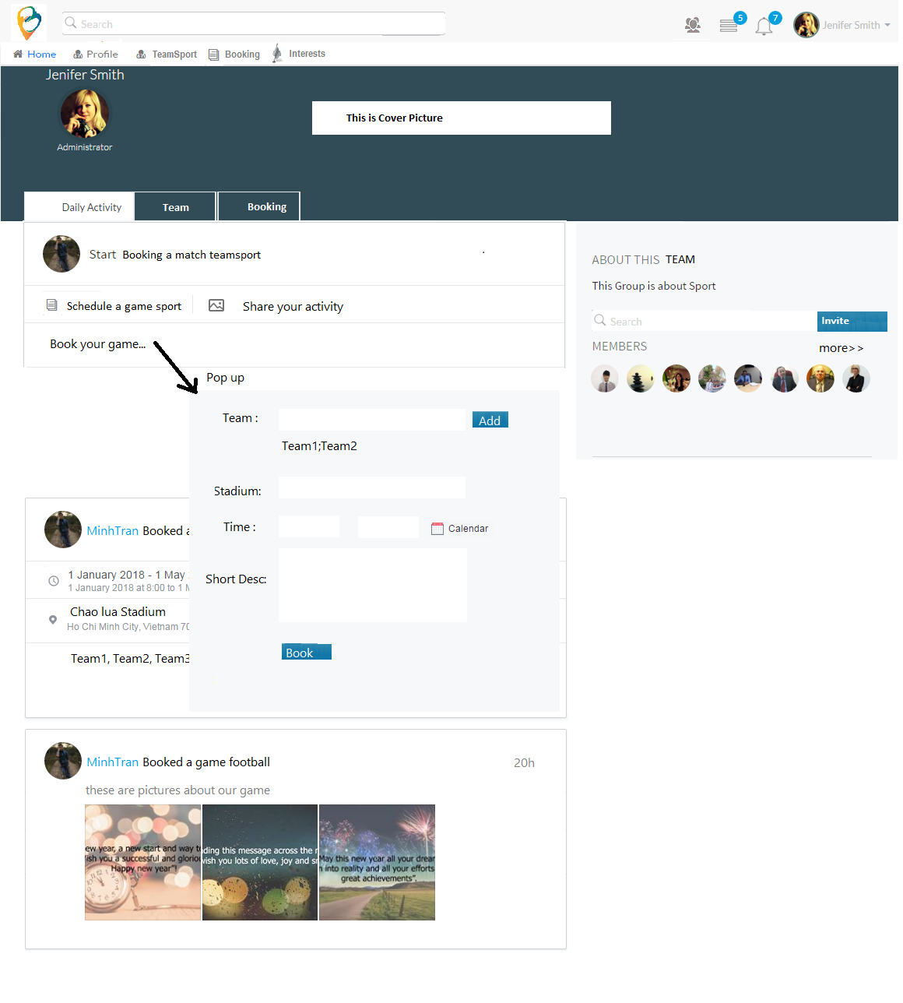

Remove this picture

**Booking in Team:**

* Each member of team has privilege to book a game sport and Share activity (post ) in Team page. These are roles of member in team
* Reject request which has been received by team
* Booking a game sport (delete, Edit)
* Share activity of team (post) (delete, Edit)
* Send Request to add member to team
* Admin of team is the root person to manage team’s page including these roles:
* Reject member
* Reject request
* Add member
* Booking a game sport
* Share activity of team (post)
* Send Request to user to add member to team
* Root person can delete any post and booking which member of team booked or posted before

## Booking event notification in Team:

Booking was published by members in team. One Request will be composed two notifications in System to send out all members in team to inform the schedule of game.

The first is notification announcement to be sent to all members as below picture:

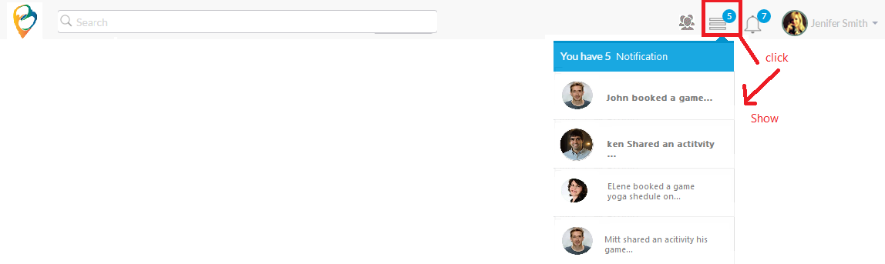

The second is notification alarm of schedule game to be sent all members as below picture:

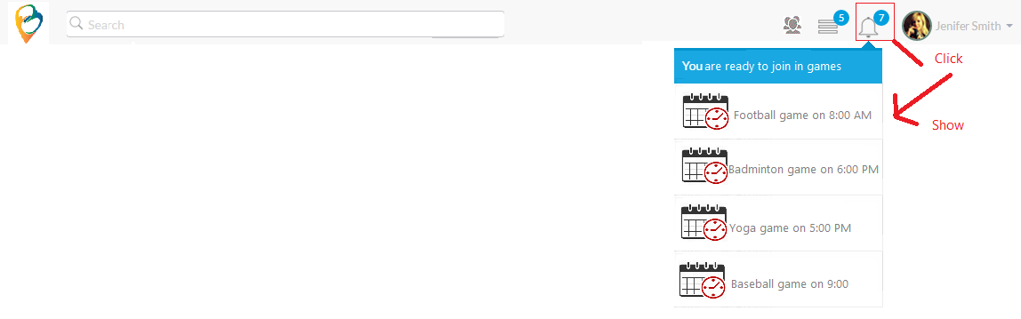

## Booking Transaction time:

The limitation time for each booking is 2 minutes maximum.

Success of booking always is priority on the less session if in the case, having two booking happen in the same time on the same stadium as well as the same available time of game

**Posting Event notification in Team:**

When any member shares any activity of team on team’s page. One request will be composed one notification in system and then sending to all members to inform.



**Invitation member event in Team:**

Any member input data in search box from right side component in team’s page, the system will search member in Bsportteam and show up data result like input of user. When member search successfully user that want to add into team, member click button “Invite” like pic below

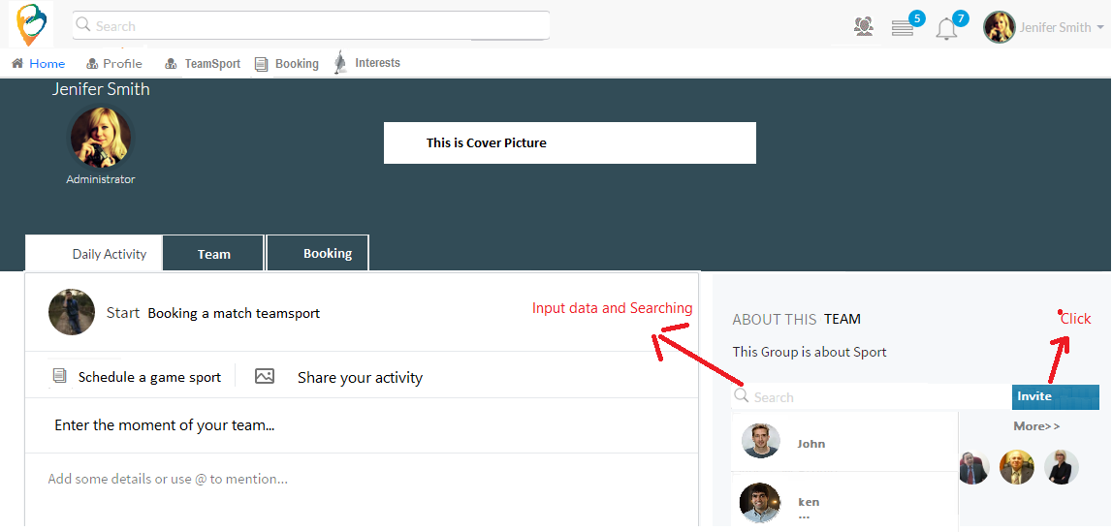

Remove this picture

One Request will be composed in System to send out admin in team to inform and concurrent one notification will be sent to administrator

When administrator click “Accept” button to agree addition joining of new member in team, the system sends out notification announcement to user in the case user is anonymous. In the case member of team invite another user to join this team. One request will be sent to administrator and concurrent one notification will be sent to administrator after admin click “ accept” button, one request invitation will be sent to User and concurrent one notification will be sent to administrator then if user click “ accept “ button , that time is official member

